LESSON PLAN
OUTDOOR / ECOLOGICAL EDUCATION
TITLE: Bug hunt
TRAINER: Giuseppe Perrotti
TIME REQUIRED: 90 minutes
AGE TARGET: 6-14 years

LESSON OBJECTIVE: To learn outdoors, develop motor skills, focus and refocus attention, association of item/meaning and generalization of the meaning, cooperation. Inclusion between neurotypical and neuro diverse.
MATERIALS USED: List of insect silhouettes, one cell phone with camera for pair of students.
LESSON OUTLINE:
- The trainer splits the students in as many groups of two as possible. When not possible, a group of three will be allowed.
- Each group receives a copy of the insect silhouettes list.
- Each team has to find at least one insect from the list, take a picture of it and check the accomplishment box next to the insect’s image.
- At the end of the activity, all pictures are collected, printed and labeled with the corresponding name of the insect.
REFLECTION:
Ask about the different insect’s life, their characteristics and what makes them really different from one another.
- Atistic children have the chance, with this activity, to associate the insect’s image with the real-life bug. The multitude of different shapes and colors for the same bugs, would help develop the ability to generalize definitions.
- By working together, neurotypicals and neurodiversity have the chance to expose one another to each other’s differences and strengths.
- In the end students will have a better understanding of local insect’s life, ecology and their personal position compared to that of the ecosystem around them.

Activity realized with the school director and the Erasmus coordinator of a school of the Aruba island in October 2022 in Soverato connected with the topic of Special Needs kids and inclusion.
Some pictures
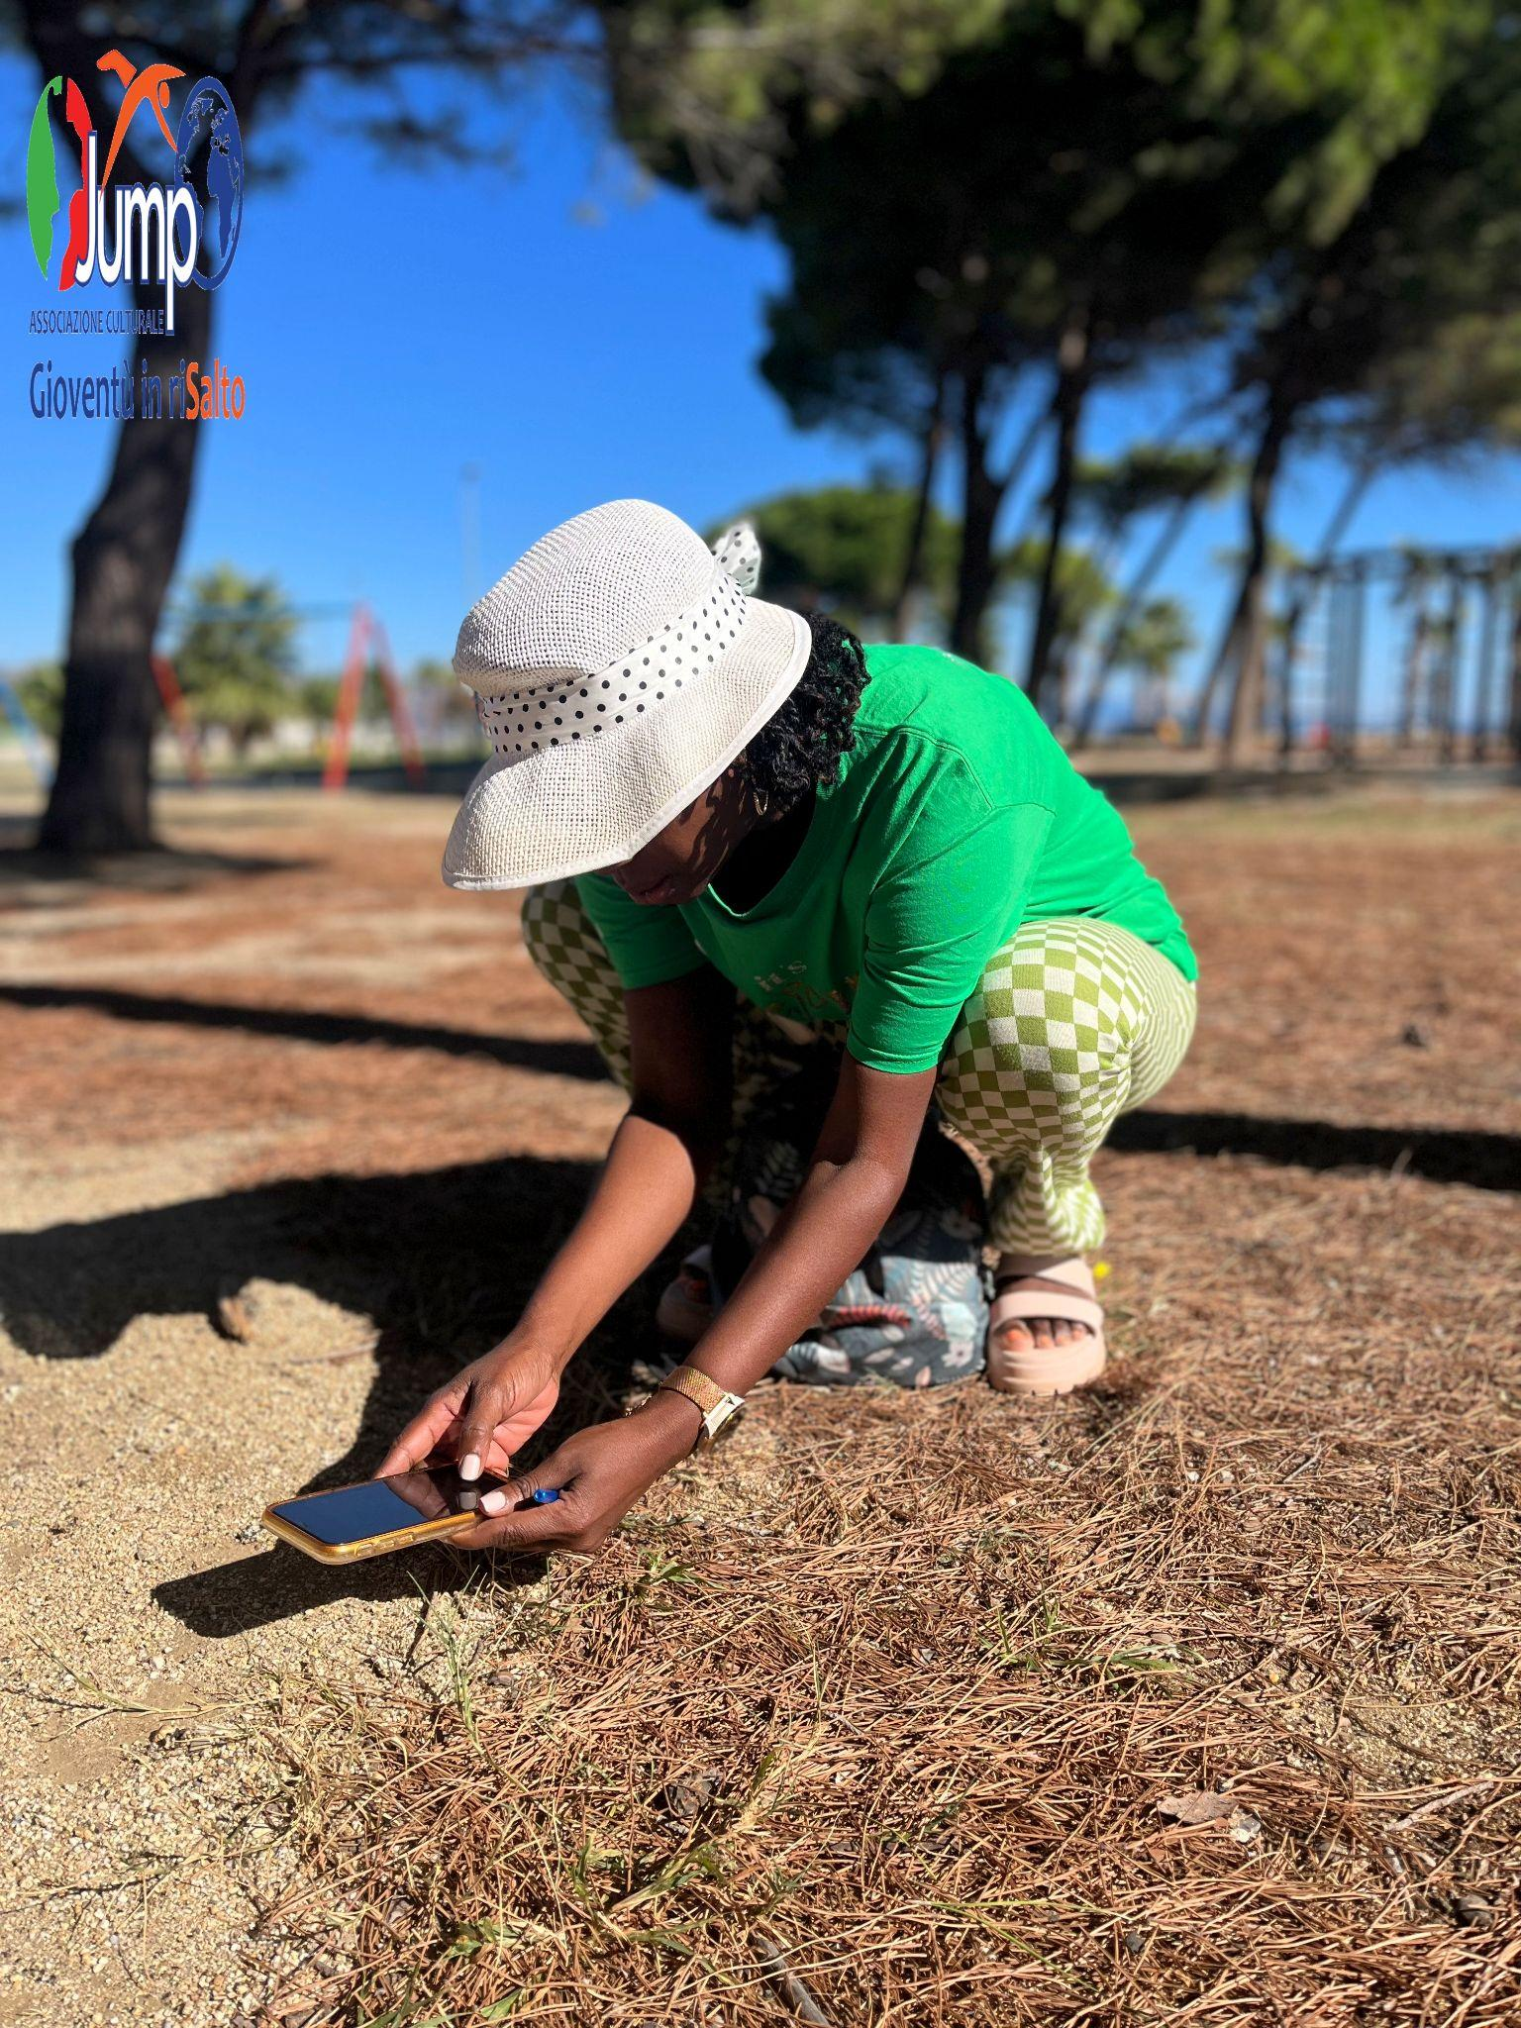 | 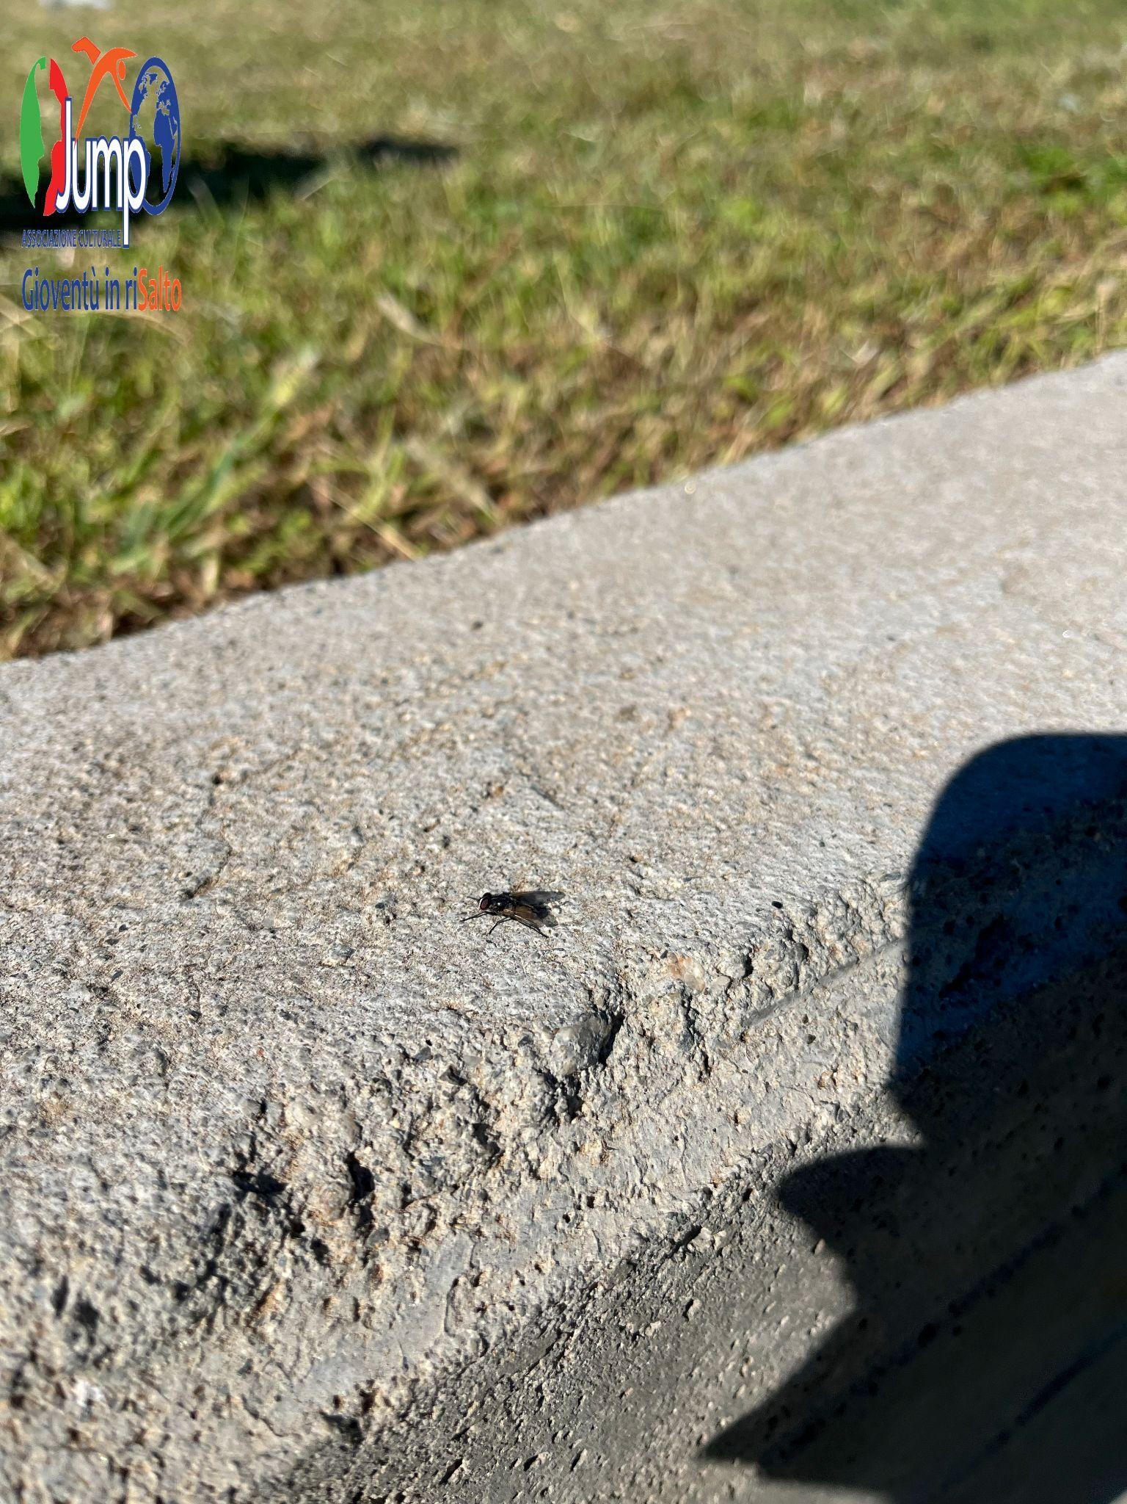
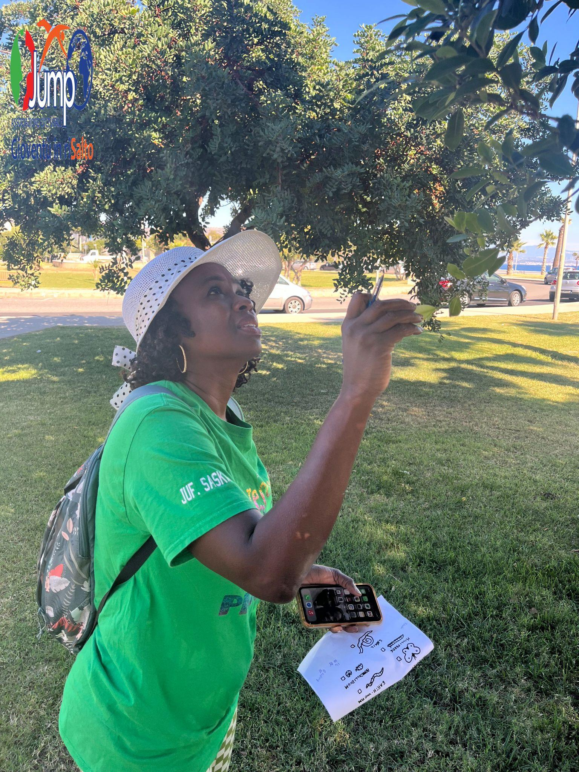 | 